FAQ Discount & Approvals SuperOffice 2026 and beyond

Content
Introduction 2
General 2
Discount Policy Overview – CRM Suite vs Legacy Models 2
Key Takeaways 2
Software 3
Tier 1: Discount thresholds for Sales reps 3
Tier 2: Discount thresholds for CD´s 3
Tier 3: Discount above CD threshold 3
Credit notes - Procedure & approval 6
Services 7
Discount on services & Approved non billable 7

Introduction

This document describes the current Discount thresholds and associated approval process.

General

The Discount thresholds described in this document and the approval processes is applicable for both CRM Suite price model and Legacy price model. The discounting methods allowed for CRM Suite vs Legacy price model deviate, please see table in next section for details.
Invoicing periods: Standard invoicing periods are 12 months. If customer prefers another invoicing period, this should be a part of the commercial negotiations.
In the event of a license quantity reduction, the license line item with the highest applied discount shall be reduced first

Discount Policy Overview – CRM Suite vs Legacy Models

This overview highlights the key differences between CRM Suite discount rules and legacy SuperOffice pricing models. The purpose is to ensure clarity, consistency, and correct application of discount policies.
Topic | CRM Suite | Legacy Models
Discount Type | Only Introduction Discount allowed (temporary, order-level) | Line discounts (permanent) and Order discounts (temporary)
Scope of Discount | Applies to entire order at time of purchase | Can be applied per line or entire order
Validity Period | Defined period (from specific start to end date) | Either ongoing (line) or first invoice period (order)
Renewal Behavior | Discount expires at renewal – customer pays full price | Discount may continue if applied as line discount
Additional Licenses | New Introduction Discount can be applied until subscription end date; expires at renewal | Additional licenses follow standard discount rules and approvals

Key Takeaways
CRM Suite enforces a non-permanent-discount model to protect long-term pricing integrity
All CRM Suite discounts are temporary and must expire at renewal

Software

Tier 1: Discount thresholds for Sales reps

The discount level which Sales reps can approve (no additional approvals required) are set to:
- Buy: 5%
- Subscriptions: 5%
- Metered services : 5%
- Migration to Online: 20%

This is already reflected in ONE.
For approvals higher than the above, please follow your normal approval flow to the CCD, exactly same process as before the new levels.
An important task, is to start planning for how to address the discount levels when the contracted period expires.

Tier 2: Discount thresholds for CD´s

The discount level which CD´s can approve (no additional approvals required) are set to:
- Buy: 40%
- Subscriptions: 40%
- Metered services : 40%
- Migrations to Online: 40%
- Migration to Onsite no additional approvals needed above CCD level
- For customers that already have registered” More discount” agreements with a higher discount than the new thresholds no additional approvals needed above CCD level

Tier 3: Discount above CD threshold

For Discounts higher than the CD threshold, approval from Bjørn should be obtained.
We have created a form in ONE to support the approval flow to Bjørn.
See below for step by step guide.
How to create a discount approval request
Go to the sale where you want to create a discount approval request.
Click on “Task” and this view will be shown:
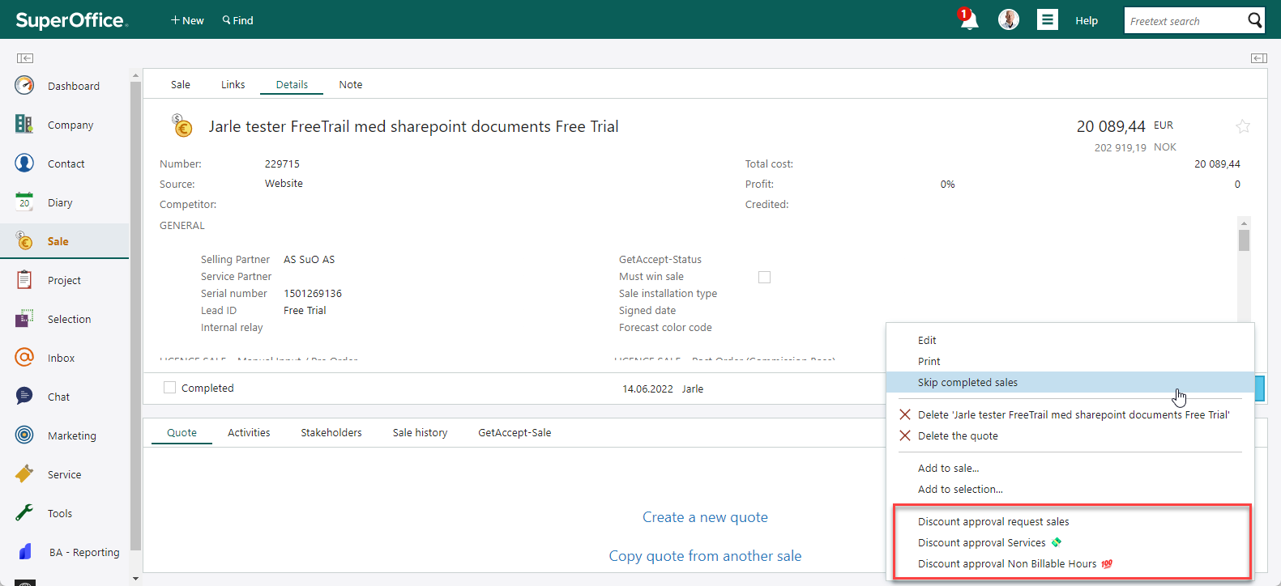
Click on i.e for sale “Discount approval request sale” and this view will be shown:
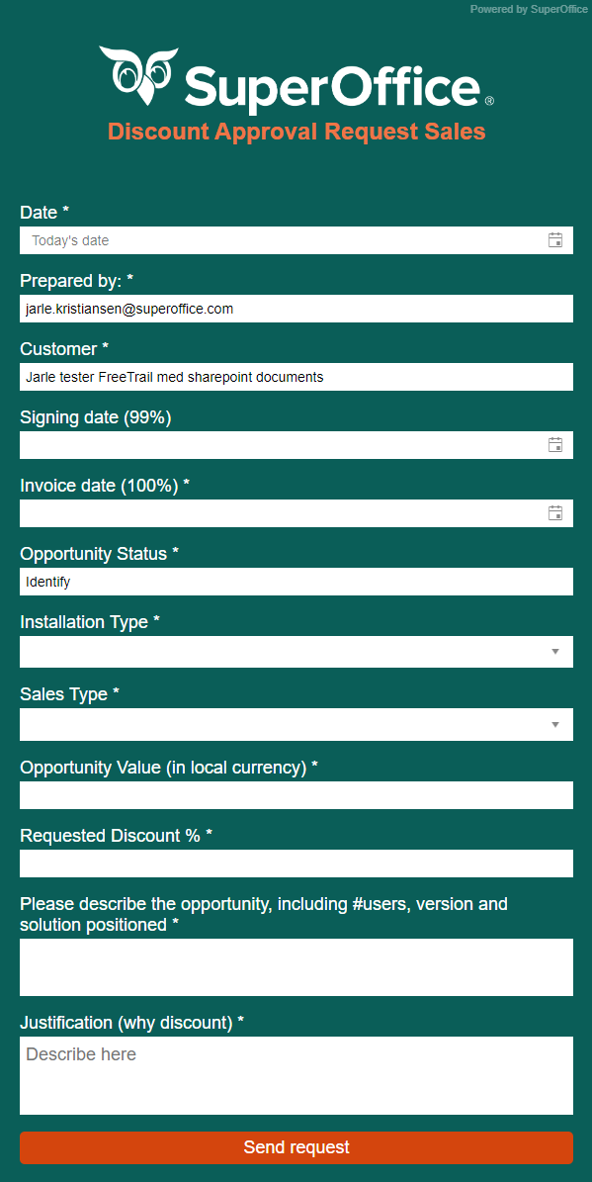
Fill out the fields and click “Send request”
This will create a request for management.
Management will reply on the request and approve the discount or disapprove the discount (or ask more questions).
When you get your reply you can archive this in SuperOffice and connected it to the sale.

Partner opportunities
Partner discount approvals will have same approval process as direct deals.

Credit notes - Procedure & approval

All credit note requests in country, needs to be approved by local CCD, and sent to QTC team service category for processing.
All credit notes with backward P&L effect above 50’ NOK need to be sent by CCD to Finance/Marianne for alignment. P&L effect calculated in MRR accumulated by number of months overdue.”

Services

Discount on services & Approved non billable

Local NSR´s can approve both discount and non-billable work
No further approvals needed.

